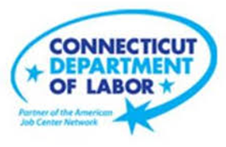

**NEW WEEKLY JOB POSTINGS FROM   
HELP WANTED ONLINE  
Office of Research**

**Week Ending July 16th, 2022: Total New Ads Increase to Over 11,000**WETHERSFIELD, July 22nd, 2022 – During the week ending July 16th, there were 11,106 new postings, up 375 new ads or +3% over the week. Employers with large over the week increases include Thriveworks, Connectrn, and Yale-New Haven Health Network. Employers with the largest new ad decrease over the week include The Home Depot, Masonicare Corp., and Walmart/Sam’s. Occupations with the largest over the week increases include Pharmacy Technicians (+78 new ads), Restaurant Cooks (+51 new ads), and Merchandise Displayers & Window Trimmers (+49 new ads). This weekly new ad level is the 7th week of 2022 over 10,000 new ads and over twice the level from a year ago. Compared to a year ago, the industries up the most new ads include Health Care & Social Assistance (+1,328 new ads over 52 weeks), Pro., Sci., & Tech. (+733 news over 52 weeks), and Finance & Insurance (+685 new ads over 52 weeks).  
  
  
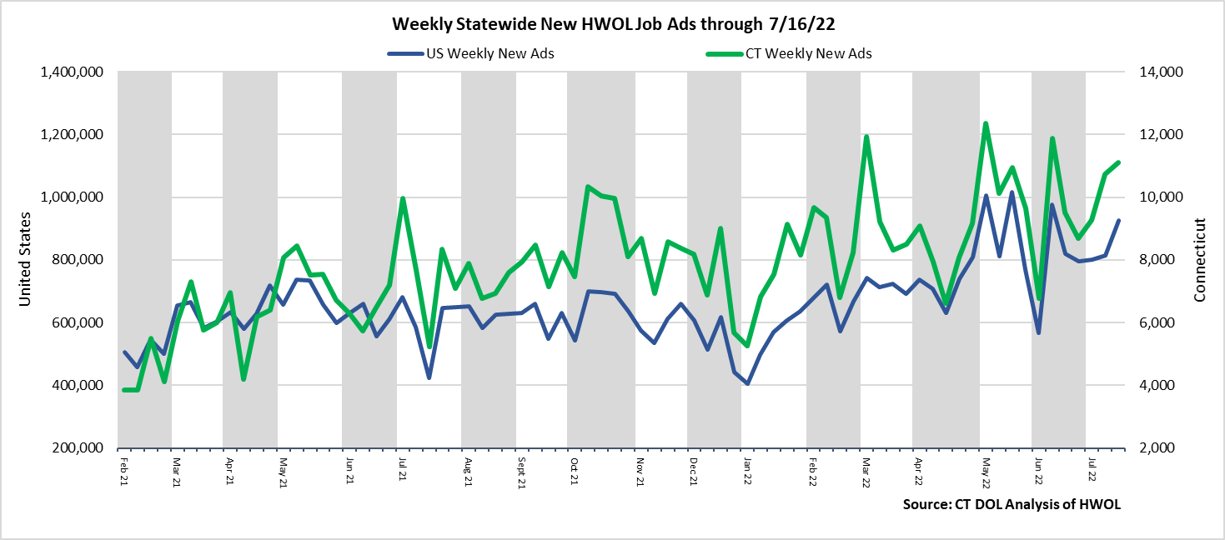  
**Industries** with the most new postings include Health Care & Social Assistance, Finance & Insurance, and Pro., Sci., & Tech. Services.

**Occupations** with the most new postings include Registered Nurses, Heavy & Tractor Trailer Truck Drivers, and Retail Salespersons.

**Employers** with the most new postings include Deloitte, Capital One, and Yale-New Haven Health Systems.

**The three industries with the most new job postings were:**

* **Health Care & Social Assistance** (2,132 new postings, +7% over the week)
* **Finance & Insurance** (1,099 new postings, +10% over the week)
* **Professional, Scientific, and Technical Services** (1,057 new postings, +19% over the week)

  
 During the week ending July 16th, 2022, the total ad increase of 375 new ads or +3% is the net result of increases in 14 of 21 industries. This slight top-line gain overlays larger industry level change. The 14 increasing industries were up a combined 1,284 new ads, with the largest gains occurred in Health Care & Social Assistance (+235 new ads), Pro., Sci., & Tech., (+167 new ads) and Manufacturing (+161 new ads). The 7 decreasing industries were down a combined 909 new ads, with most of that occurring in Accommodation & Food Services (-381 new ads) and Retail Trade (-375 new ads). Over four weeks, total new ads are up 17% or +1,605 new ads. Half of the four-week increase occurred in Pro., Sci., & Tech. (+347 new ads), Transportation & Warehousing (+238 new ads), and Accommodation & Food Services (+236 new ads).  
   
 For more information on total job ads by industry for Connecticut and its labor market areas, see the monthly report available here: <https://www1.ctdol.state.ct.us/lmi/hwol.asp>

**New Job Postings by Occupation** 

**The occupations with the most new postings were:**

* Registered Nurses (435 new postings, +12% over the week)
* Heavy & Tractor Trailer Truck Drivers (382 new postings, +13% over the week)
* Retail Salespersons (273 new postings, -28% over the week)

**Employers with the Most New Job Postings**

Employers with the most new job postings during the week were mostly in Healthcare & Social Assistance, Finance & Insurance, and Pro., Sci., & Tech. Services. The 25 employers shown above account for 19 percent of all new ads. 22 of 25 employers in the top 25 had over the week increases. The largest increases in the top 25 include Thriveworks (+104 new ads), Connectrn (+90 new ads), and Yale-New Haven Health System (+78 new ads). Over four weeks, 21 employers in the top 25 had increases and 4 had decreases. The largest four week increases include Deloitte (+342 new ads), Thriveworks (+116 new ads) and Masonic Corp. (+102 new ads).  
  
**What is HWOL?**The **Conference Board Help Wanted Online**® Data Series (HWOL) measures the number of new, first-time Online job postings and jobs reposted from the previous month for over 16,000 Internet job boards, corporate boards and smaller job sites that serve niche markets and smaller geographic areas. To view more HWOL data, go to: <https://www1.ctdol.state.ct.us/lmi/hwol.asp>